Online Meta-Learning

1. Introduction

Meta-learning deals with learning to learn, but neglects the sequential and non-stationary aspects of the problem. Online learning offers an appealing theoretical framework, but does not generally consider how past experience can accelerate adaptation to a new task. In this work, we motivate and present the online meta-learning problem setting, where the agent simultaneously uses past experiences in a sequential setting to learn good priors, and also adapt quickly to the current task at hand.

Meta-learning offers an appealing solution: by learning how to learn from past tasks, we can make use of task structure and extract information from the data that both allows us to succeed on the current task and adapt to new tasks more quickly.

2. Foundations

2.1. Few-Shot Learning

2.2. Meta-Learning and MAML

Meta-learning, or learning to learn, aims to bootstrap from a set of tasks to learn faster on a new task.

Meta-learning algorithms attempt to find a model using the *M* training tasks, such that when D*j* is revealed from the test task, the model can be quickly updated to minimize *fj*(**w**).

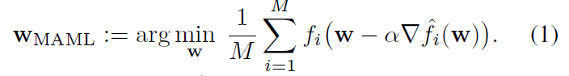

2.3. Online Learning

In online learning, an agent faces a sequence of loss functions {*ft*}OE*t*=1, one in each round *t*.

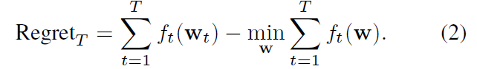

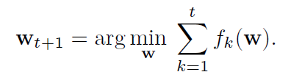

3. The Online Meta-Learning Problem

We consider a sequential setting where an agent is faced with tasks one after another.

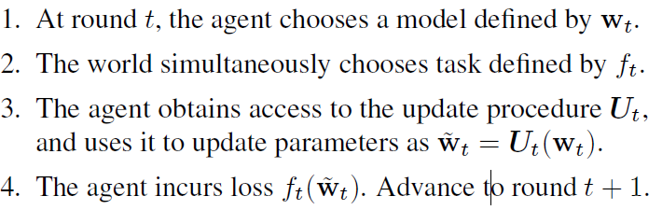

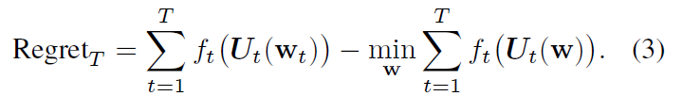

4. Algorithm and Analysis

4.1. Follow the Meta Leader

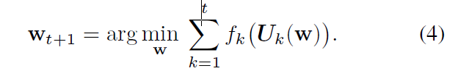

4.2. Assumptions

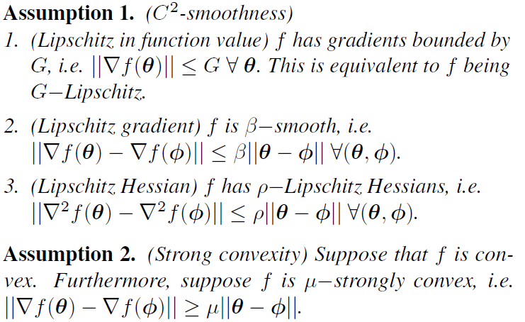

4.3. Analysis

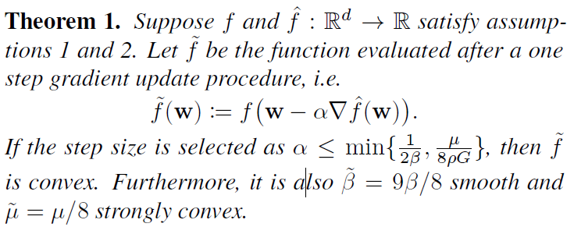

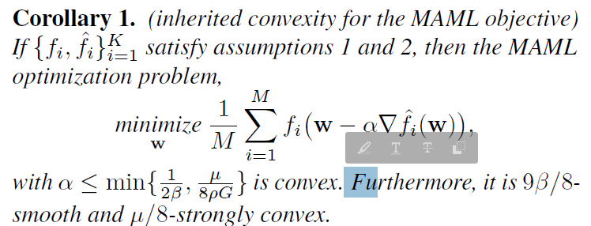

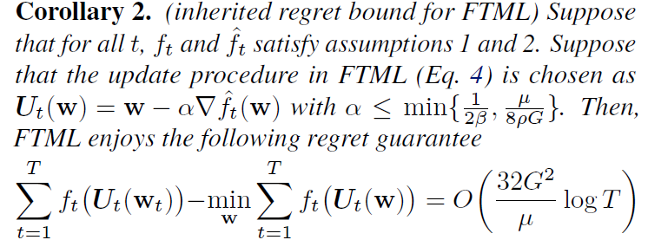

5. Practical Online Meta-Learning Algorithm

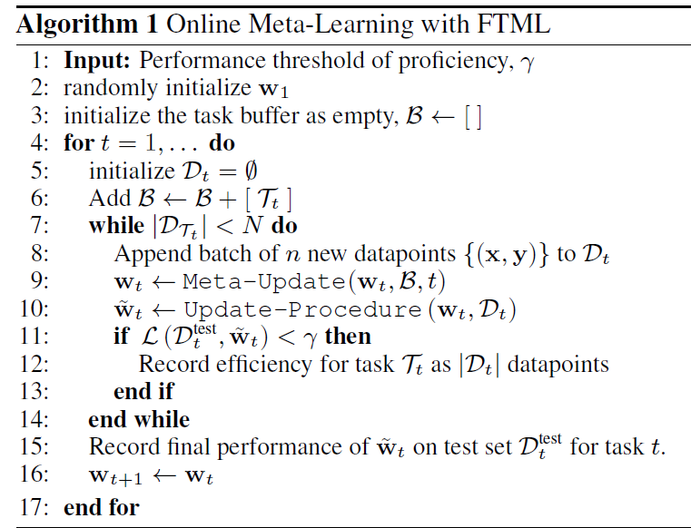

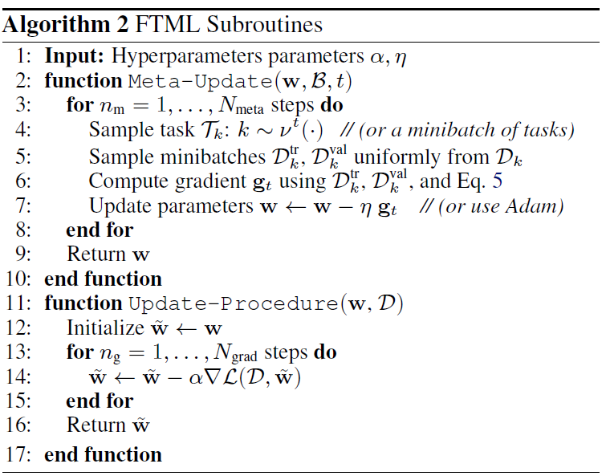

6. Experimental Evaluation

6.1. Rainbow MNIST

6.2. Five-Way CIFAR-100

6.3. Sequential Object Pose Prediction

7. Connections to Related Work

Meta-learning

Continual learning

Online learning

8. Discussion and Future Work